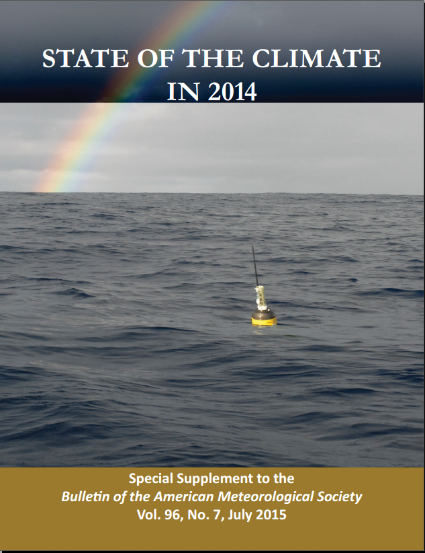
Most of the dozens of essential climate variables monitored each year in this report continued to follow their long-term trends in 2014, with several setting new records. Carbon dioxide, methane, and nitrous oxide—the major greenhouse gases released into Earth’s atmosphere—once again all reached record high average atmospheric concentrations for the year.Carbon dioxide increased by 1.9 ppm to reach a globally averaged value of 397.2 ppm for 2014. Altogether, 5 major and 15 minor greenhouse gases contributed 2.94 W m–2of direct radiative forcing, which is 36% greater than their contributions just a quarter century ago.

Accompanying the record-high greenhouse gas concentrations was nominally the highest annual global surface temperature in at least 135 years of modern record keeping, according to four independent observational analyses. The warmth was distributed widely around the globe's land areas, Europe observed its warmest year on record by a large margin, with close to two dozen countries breaking their previous national temperature records; many countries in Asia had annual temperatures among their 10 warmest on record; Africa reported above-average temperatures across most of the continent throughout 2014; Australia saw its third warmest year on record, following record heat there in 2013; Mexico had its warmest year on record; and Argentina and Uruguay each had their second warmest year on record. Eastern North America was the only major region to observe a below-average annual temperature.

But it was the oceans that drove the record global surface temperature in 2014. Although 2014 was largely ENSO-neutral, the globally averaged sea surface temperature (SST) was the highest on record. The warmth was particularly notable in the North Pacific Ocean where SST anomalies signalled a transition from a negative to positive phase of the Pacific decadal oscillation. In the winter of 2013/14, unusually warm water in the northeast Pacific was associated with elevated ocean heat content anomalies and elevated sea level in the region. Globally, upper ocean heat content was record high for the year, reflecting the continued increase of thermal energy in the oceans, which absorb over 90% of Earth’s excess heat from greenhouse gas forcing. Owing to both ocean warming and land ice melt contributions, global mean sea level in 2014 was also record high and 67 mm greater than the 1993 annual mean, when satellite altimetry measurements began. Sea surface salinity trends over the past decade indicate that salty regions grew saltier while fresh regions became fresher, suggestive of an increased hydrological cycle over the ocean expected with global warming. As in previous years, these patterns are reflected in 2014 subsurface salinity anomalies as well. With a now decade-long trans-basin instrument array along 26°N, the Atlantic meridional overturning circulation shows a decrease in transport of –4.2 ± 2.5 Sv decade^{–1}
.
Precipitation was quite variable across the globe. On balance, precipitation over the world’s oceans was above average, while below average across land surfaces. Drought continued in southeastern Brazil and the western United States. Heavy rain during April–June led to devastating floods in Canada’s Eastern Prairies. Above-normal summer monsoon rainfall was observed over the southern coast of West Africa, while drier conditions prevailed over the eastern Sahel. Generally, summer monsoon rainfall over eastern Africa was above normal, except in parts of western South Sudan and Ethiopia. The south Asian summer monsoon in India was below normal, with June record dry.

Across the major tropical cyclone basins, 91 named storms were observed during 2014, above the 1981–2010 global average of 82. The Eastern/Central Pacific and South Indian Ocean basins experienced significantly above-normal activity in 2014; all other basins were either at or below normal. The 22 named storms in the Eastern/Central Pacific was the basin's most since 1992. Similar to 2013, the North Atlantic season was quieter than most years of the last two decades with respect to the number of storms, despite the absence of El Niño conditions during both years.
In higher latitudes and at higher elevations, increased warming continued to be visible in the decline of glacier mass balance, increasing permafrost temperatures, and a deeper thawing layer in seasonally frozen soil. In the Arctic, the 2014 temperature over land areas was the fourth highest in the 115-year period of record and snow melt occurred 20–30 days earlier than the 1998–2010 average. The Greenland Ice Sheet experienced extensive melting in summer 2014. The extent of melting was above the 1981–2010 average for 90% of the melt season, contributing to the second lowest average summer albedo over Greenland since observations began in 2000 and a record-low albedo across the ice sheet for August. On the North Slope of Alaska, new record high temperatures at 20-m depth were measured at four of five permafrost observatories.

In September, Arctic minimum sea ice extent was the sixth lowest since satellite records began in 1979. The eight lowest sea ice extents during this period have occurred in the last eight years. Conversely, in the Antarctic, sea ice extent countered its declining trend and set several new records in 2014, including record high monthly mean sea ice extent each month from April to November. On 20 September, a record large daily Antarctic sea ice extent of 20.14 × 10⁶km² occurred.

The 2014 Antarctic stratospheric ozone hole was 20.9 million km²when averaged from 7 September to 13 October, the sixth smallest on record and continuing a decrease, albeit statistically insignificant, in area since 1998.

